**LAB 1 ASSIGNMENT**

**1. Describe Operating System.**

**=>** An **Operating system (OS)** is a software which acts as an interface between the end user and computer hardware. Every computer must have at least one OS to run other programs. An application like Chrome, MS Word, Games, etc. needs some environment in which it will run and perform its task. The OS helps you to communicate with the computer without knowing how to speak the computer's language. It is **not** possible for the user to use any computer or mobile device without having an operating system.

**2. Types of Operating Systems.**

* **Batch Operating System :** In this type of OS, every user prepares his or her job on an offline device like a punch card and submit it to the computer operator.
* **Multitasking/Time Sharing OS :** Time-sharing operating system enables people located at a different terminal(shell) to use a single computer system at the same time. The processor time (CPU) which is shared among multiple users is termed as time sharing.
* **Real Time OS :** A real time operating system time interval to process and respond to inputs is very small. Examples: Military Software Systems, Space Software Systems.
* **Distributed OS :** Distributed systems use many processors located in different machines to provide very fast computation to its users.
* **Network OS :** Network Operating System runs on a server. It provides the capability to serve to manage data, user, groups, security, application, and other networking functions.

**3. Features of Operating System.**

* Handling I/O operations
* Manipulation of the file system
* Program Execution
* Resources management
* Error detection and handling
* Data security

**4. Linux Architecture .**

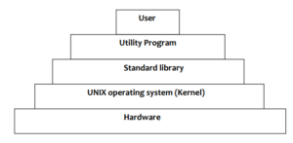

**Hardware :** it contains the physical devices as CPU, memory, I/O devices etc. Kernel . it is the central program which have full access to the resources of the OS.

**Kernel :** it is the central program which have full access to the resources of the os.

**Standard Library :** it contains set of procedures. This is collection of system level files.

**Utility Program :** Used to make user programs and make work easier. Eg- compilers, editors etc.

**User interacts with the system.**

**5. Define shell and kernel with eg.**

The kernel is the central component of a computer operating systems. The only job performed by the kernel is to the manage the communication between the software and the hardware. A Kernel is at the nucleus of a computer. It makes the communication between the hardware and software possible. While the Kernel is the innermost part of an operating system, a shell is the outermost one. **For example** the Linux **kernel** is used numerous **operating** systems including Linux, FreeBSD, Android and others.

When a user gives his Command for Performing Any Operation, then the Request Will goes to the Shell Parts, The Shell Parts is also called as the Interpreter which translate the Human Program into the Machine Language and then the Request will be transferred to the Kernel. So that Shell is just called as the interpreter of the Commands which Converts the Request of the User into the Machine Language. Some **examples** of **shells** are MS-DOS **Shell** (command.com), csh, ksh, PowerShell, sh, and tcsh.

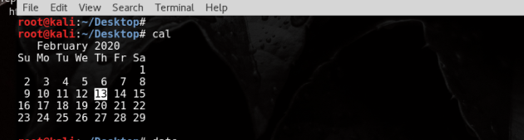6. Commands

cal:

ncal:

date:

man date:

date –s:

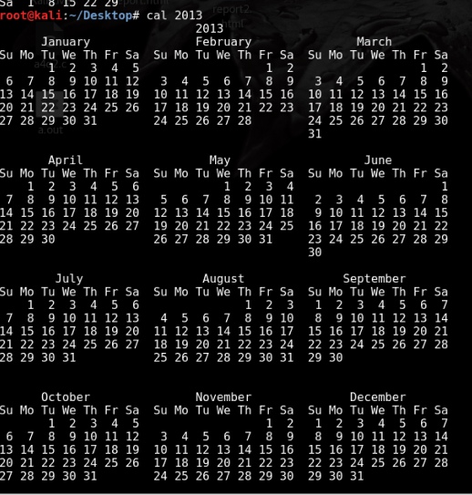cal 2013 :

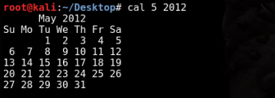Cal 5 2013 :

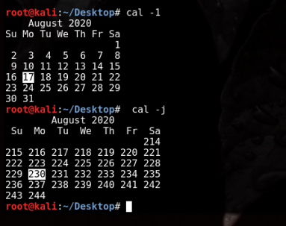Cal -1:

Cal –j: